A

PROJECT REPORT

ON

**“LAPTOP AND DESKTOP RENTAL SYSTEM”**

Towards partial fulfilment of the requirement in

**4th Semester BCA (2022)**

**Submitted by:**

Harshil Patel (210510123009)

Shaikh Yaman (210510123012)

Sai Shankar Majji (210510124013)

**Submitted To:-**



**Parul Institute of Computer Application,**

**Parul University.**

Under the guidance of

Assistant Professor

Divyakumar Shah

**Acknowledgement**

*The success and final outcome of this project required a lot of guidance and assistance from many people and we are extremely privileged to have got this all along the completion of our project. All that we have done is only due to such supervision and assistance and we would not forget to thank them.*

*We respect and thank Dr Priya Swaminarayan, Dean, FITCS for providing us an opportunity to do the project work in BCA and giving us all support and guidance, which made us complete the project duly. We are extremely thankful to Mam for providing her support and guidance, although she had busy schedule managing the academic affairs.*

*We would not forget to remember Prof. Hina Chokshi, HOD, BCA department for her encouragement and more over for her timely support and guidance till the completion of our project work.*

*We owe our deep gratitude to our project guide Prof. Divyakumar Shah, who took keen interest on our project work and guided us all along, till the completion of our project work by providing all the necessary information for developing a good system.*

*We are thankful to and fortunate enough to get constant encouragement, support and guidance from our Parents, all Teaching staffs of BCA Department which helped us in successfully completing our project work. Also, we would like to extend our sincere esteems to all staff in laboratory for their timely support.*

***[Harshil Nilesh Patel] [210510123009]***

***[Shaikh Yaman] [210510123012]***

***[Sai Shankar Majji] [210510124013]***



PARUL INSTITUTE OF COMPUTER APPLICATION

**CERTIFICATE**

This is to certify that ***Harshil Nilesh Patel, Shaikh Yamanuddin, Shankar Majji*** the student(s) of Parul Institute of Computer Application, has/have satisfactorily completed the project entitled “***_Laptop And Desktop Rental_****”* as a part of course curriculum in BCA / IMCA semester-V for the academic year 2021-2022 under guidance of ***prof. Divyakumar shah_.***

Enrollment Number: 210510123009

Enrollment Number: 210510123012

Enrollment Number: 210510124013

|  |  |  |
| --- | --- | --- |
| **Quality of work** | **Grade** | **Sign of Internal guide** |
| **Poor / Average / Good /**  **Excellent** | **B /B+ / A / A+** |  |

Date of submission:

HOD, Principal,

**Prof. Hina Chokshi** **Dr Priya Swaminarayan**

**INDEX**

|  |  |
| --- | --- |
| **Content** | **Page No.** |
| 1. Research | 1 |
| 1. Feasibility Studies | 2 |
| * 1. Technical Feasibility | 2 |
| * 1. Economic Feasibility | 2 |
| * 1. Operational Feasibility | 2 |
| 1. System Requirement Specification | 5 |
| * 1. Introduction to SRS | 5 |
| * 1. Abstract | 6 |
| * 1. System Users | 7 |
| * 1. Modules | 7 |
| * 1. Modules Description | 7 |
| * 1. Hardware / Software Requirement | 8 |
| * 1. Flow Chart | 9 |
| * 1. TimeLine Chart | 10 |
| 1. Technology Description | 10 |
| * 1. Features and Limitations of New System | 10 |
| 1. Data Flow Diagram | 11 |
| * 1. Context Level DFD’s | 11 |
| * 1. Level 1 DFD’s | 12 |
| * 1. Level 2 DFD’s | 14 |
| * 1. Level 3 DFD’s |  |
| 1. Use Case Diagram | 16 |
| 1. Class Diagram | 17 |
| 1. Activity Diagram | 18 |
| * 1. Description of Activity Diagram | 20 |
| 1. E-R Diagram | 21 |
| * 1. E-R Diagram Description | 22 |
| 1. Data Dictionary | 23 |
| * 1. Description of Data Dictionary | 26 |
| 1. Form Design (Screenshots Phase 1, 2, 3, 4 and Validation’s Screenshots) | 27 |
| 1. What is Testing? | 29 |
| * 1. Importance and Types of Testing | 29 |
| 1. Future Enhancement | 30 |
| 1. References and Bibliography | 31 |

1. **Research**
   1. **What is research?**

Research is the systematic investigation of a subject in order to discover new information or understand it more fully. It is a process of inquiry that involves finding and evaluating sources of information, such as data, documents, and previous studies, in order to generate new knowledge or gain a deeper understanding of a topic. Research can be conducted in a wide range of fields, including science, technology, medicine, the social sciences, and the humanities. The goal of research is to expand human knowledge and improve our understanding of the world around us.

* 1. **Types of Research Methodology**

**1.2.1 Experimental research:** This type of research involves manipulating one or more variables in order to observe the effect on another variable. This method is often used in the natural sciences, such as physics and biology, but can also be used in other fields such as psychology and economics.

**1.2.2 Observational research:** In this type of research, the researcher observes and records data without manipulating any variables. This method is often used in fields such as anthropology, sociology, and epidemiology.

**1.2.3 Surveys:** Surveys involve collecting data from a large number of individuals through questionnaires or interviews. Surveys can be conducted in person, by phone, or online.

**1.2.4 Case studies:** A case study involves an in-depth examination of a specific individual or group. Case studies can be used in fields such as psychology, sociology, and education.

1. **Feasibility Studies**

**What is Feasibility?**

Feasibility refers to the likelihood that a given project, proposal, or plan can be successfully completed, considering a variety of factors such as technical requirements, resource constraints, and potential risks. The feasibility study is a process that is used to determine whether a project should go forward or not by evaluating its technical and economic viability. It is a crucial step in the project development process, as it can help identify potential issues and roadblocks early on, before significant resources have been invested in the project.

* 1. **Technical Feasibility**

Technical feasibility refers to the assessment of whether a proposed project or solution can be completed using current technology and resources. It involves determining whether the necessary technology and equipment are available and can be acquired, and whether the project's requirements can be met within the given constraints.

* 1. **Economic Feasibility**

Economic feasibility is the process of determining the financial viability of a proposed project or investment. The goal of economic feasibility analysis is to determine whether the benefits of a project or investment outweigh the costs, and if it is likely to generate sufficient revenue to pay for itself over a certain period of time. The analysis typically involves estimates of the costs, revenues, and cash flows associated with the project, as well as an assessment of the overall economic environment and any risks involved.

* 1. **Operational Feasibility**

Operational feasibility is the measure of how well a proposed project or solution will function in the real-world environment in which it is intended to operate. It is one of three types of feasibility studies (along with technical and economic feasibility) that are often conducted as part of the process of determining whether a project is viable.

* 1. **Importance of Feasibility Studies**

Feasibility studies are an important tool for evaluating the potential success of a proposed project or venture. They are used to assess the practicality, feasibility, and sustainability of an idea, and to identify any potential issues or risks that may need to be addressed before proceeding with the project.

Feasibility studies typically include a variety of different analyses and evaluations, such as market research to assess the potential demand for a product or service, financial analysis to evaluate the potential profitability of the venture, and technical analysis to assess the feasibility of the proposed project from a technical standpoint.

The key benefits of conducting a feasibility study include:

1. Identifying potential problems early: By identifying potential issues before the project begins, you can take steps to address them, which can save time and money in the long run.
2. Determining the feasibility of the project: A feasibility study will help you determine whether the proposed project is likely to be successful and whether it is worth pursuing.
3. Identifying potential risks: Feasibility studies can help you identify potential risks and develop strategies for managing them.
4. Obtaining funding: Many investors and lenders will require a feasibility study before providing funding for a project.
5. Improving decision-making: Feasibility studies provide valuable information that can be used to make informed decisions about a project.
   1. **Feasibility Study of our Proposed System**
      1. **Technical Feasibility**:

A laptop rental system can be technically feasible with the right infrastructure and resources in place. Here are some key factors to consider when assessing the technical feasibility of a laptop rental system:

1. Hardware: The laptops themselves need to be reliable, durable, and in good working condition. They should also have the necessary specifications to meet the needs of the intended users.
2. Software: The rental system needs to have a way for users to reserve laptops, check their availability, and track their usage. This can be accomplished through a web-based application or a standalone software program. Additionally, the laptops should have all necessary software pre-installed, and system for updating and maintaining the software.
3. Security: The laptops need to be secure, both physically and electronically. This includes measures to prevent unauthorized access to the laptops themselves, as well as the data stored on them. Additionally, a way to remote wipe or lock the device will be necessary in case of lost or stolen device.
   * 1. **Economical Feasibility:**

When evaluating the economical feasibility of a laptop rental system, there are several factors to consider:

1. Start-up costs: This includes costs associated with acquiring the laptops, software licenses, and any necessary equipment (such as charging carts). You will also need to consider the costs of setting up and maintaining the system, including any website or software development that may be required.
2. Revenue: How much revenue can you expect to generate from laptop rentals? This will depend on the target market, rental prices, and demand. Consider the costs of renting a laptop, including any required deposits or insurance fees.
3. Operating costs: What are the ongoing costs of operating the rental system? This includes the cost of maintenance and repairs, software updates, and replacement of any lost or damaged laptops.
4. Competitive landscape: What other laptop rental options are available to your target market? Who are your main competitors and how do their pricing and services compare to yours?
5. Potential customer base: Who are the potential customers for your laptop rental system, and what are their needs? What are their concerns and how can you address them?
   * 1. **Operational Feasibility:**
6. Operational feasibility is an important aspect to consider when developing a laptop rental system as well. Here are some key factors to consider when evaluating the operational feasibility of a laptop rental system:
7. Resources: Does the organization have the resources, such as personnel, equipment, and funds, to implement and maintain the laptop rental system?
8. Workflow: How will the laptop rental system fit into the organization's existing workflow and processes? Will it require significant changes to existing procedures?
9. Inventory management: How will the organization keep track of the laptops available for rental? How will the organization ensure that laptops are returned in a timely manner?
10. **System Requirement Specification**
    1. **Introduction To SRS**
       1. **What is SRS?**

A software requirement specification (SRS) is a description of a software system to be developed. It lays out functional and non-functional requirements, and may include a set of user cases that describe user interactions that the software must provide.

* + 1. **Need of SRS**

In order to fully understand one’s project, it is very important that they come up with a SRS listing out their requirements, how are they going to meet it and how will they complete the project. It helps the team to save upon their time as they are able to comprehend how are going to go about the project. Doing this also enables the team to find out about the limitations and risks early on.

* 1. **Abstract**

In today’s competitive world, learning skills through a laptop or system has become a basic need for almost every student. But that requirement comes with a cost. A well configured laptop costs a lot for a middle-class family. Renting a laptop could be an alternative, but there is no secured platform to allow any user to rent one. To overcome these problems, we propose a web application called Laptop Renting System. The basic idea is to create a web application platform to rent the laptops on demand online which is available 24/7 removing the problem of high cost. This website eases the task of renting a laptop online.

* 1. **System Users**

3.1.1. User

3.1.2. Admin

* + 1. **Description of User Role** 
       1. **Admin**

The admin entity that will monitor activities, manage booking, user, and product.

* + - 1. **User**

User are the person which are register on the website and can view laptop details and make booking.

* 1. **Modules**
     1. Login module
     2. Admin module
     3. User module
  2. **Modules Description**
     1. **Admin login**

Admin can login in this module.

* + 1. **User login**

User can login in this module.

* + 1. **Admin module**

1.1 manage user: admin can block users.

1.2 manage booking: admin can approve/disapprove booking.

1.3 manage brand: admin can manage brand details.

1.4 manage car details: admin can update or add laptops details.

* + 1. **User module**

1.1 Personal Information: All personal information of user side.

1.2 View product details: All data about laptop starting from prices to versions of laptop.

1.3 View booking: All booking history.

1.4 Other Details: All other details of user are shown here.

* 1. **Hardware Requirements**

|  |  |
| --- | --- |
| **Name of Components** | **Specification** |
| Processor | Intel core I3,/I5 |
| RAM | 4GB/8GB |
| Hard Disk | 512GB/1TB |

**3.6. Software Requirements**

|  |  |
| --- | --- |
| **Name of Components** | **Specification** |
| Operating System | WindowsXP, windows10 |
| Software development Kit | Xampp Control Panel/Wamp Control Panel |
| Tools & languages | Google Chrome, Internet Explorer, MozillaFirefox |

**3.7. Flow Chart**

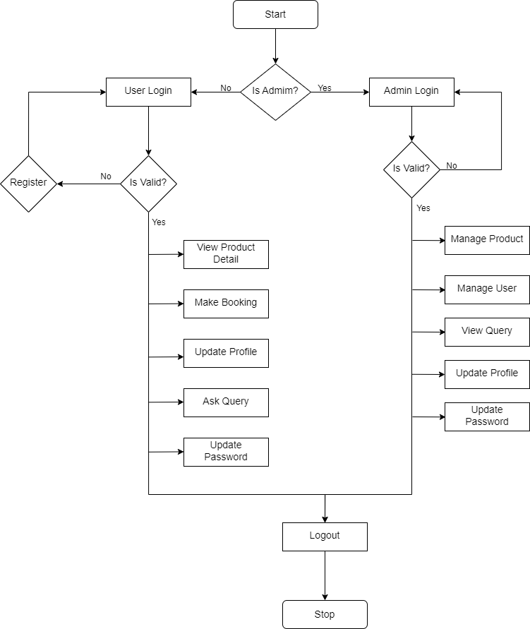

**3.8. Time Line Chart**

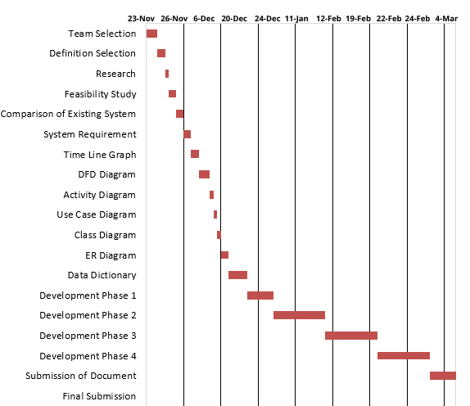

Figure 3.8.1. Time Line Chart

1. **Technology Description**
   1. **Features and Limitations of New System**

|  |  |
| --- | --- |
| **Existing System** | **New System** |
| Have payment module | No payment module |
| Have Tracking system | No tracking system |

1. **Data Flow Diagram**
   1. **Context Level DFD’s**

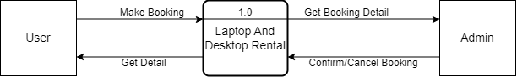

Figure 5.1.1. Context Level DFD: 0 Level

* 1. **Level 1 DFD’s:**

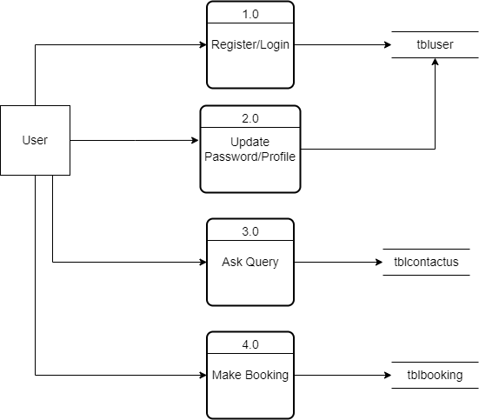

Figure 5.2.1. Context Level DFD: 1 Level

**Level 1 DFD’s**

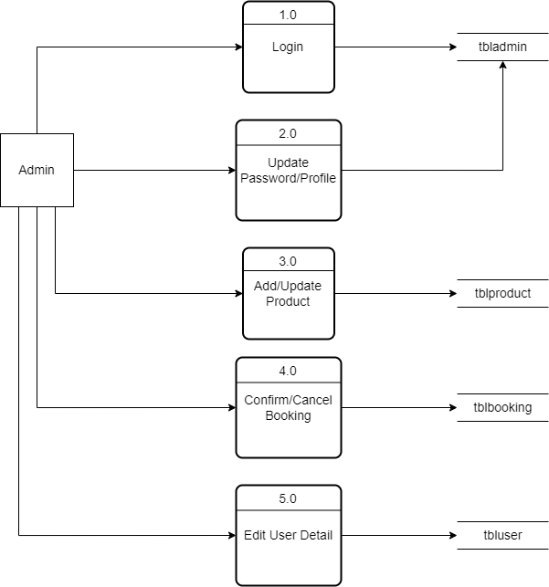

Figure 5.2.2. Context Level DFD: 1 Level

* 1. **Level 2 DFD’s:**

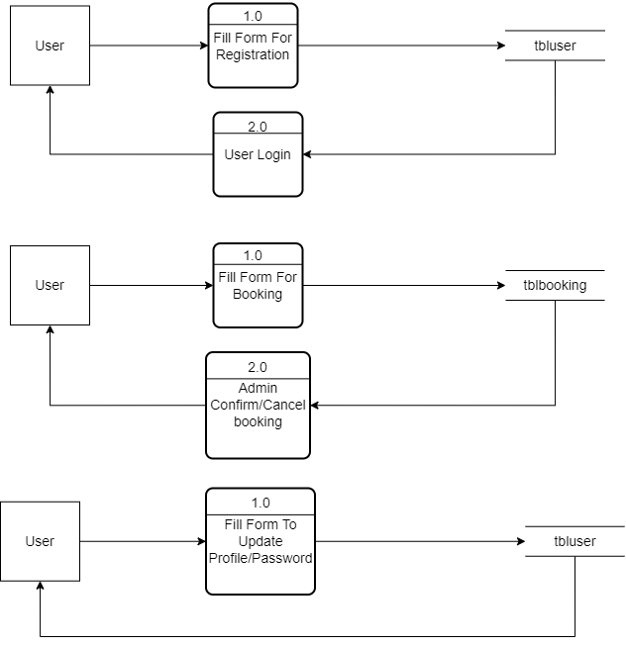

Figure 5.3.1. Context Level DFD: 0 Level

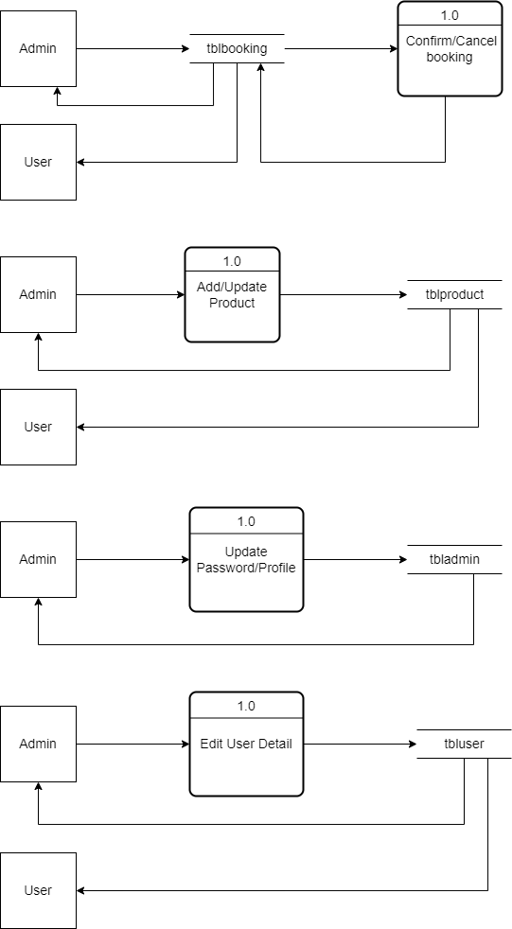

1. **Use Case Diagram**

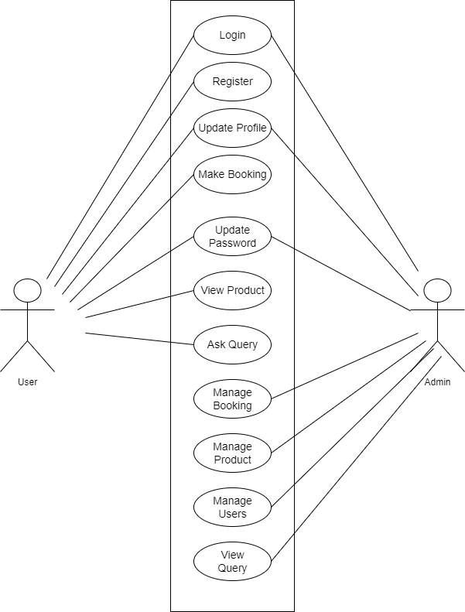

Figure 6.1.1. use case diagram.

1. **Class Diagram**

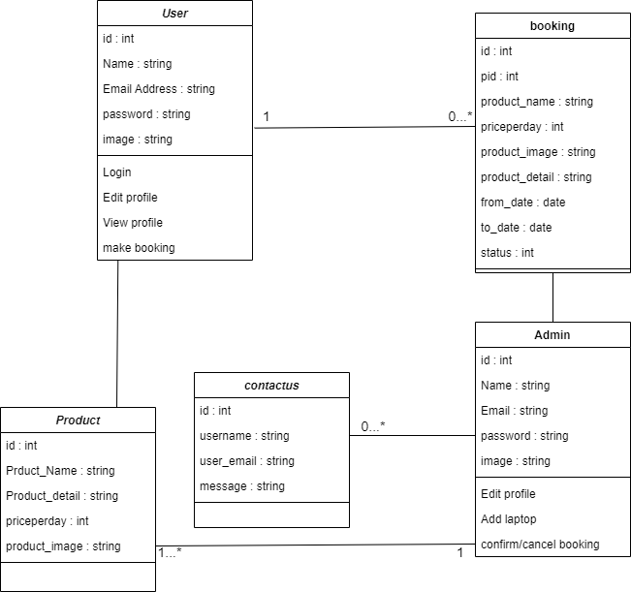

Figure 7.1.1. Class Diagram.

1. **Activity Diagram**

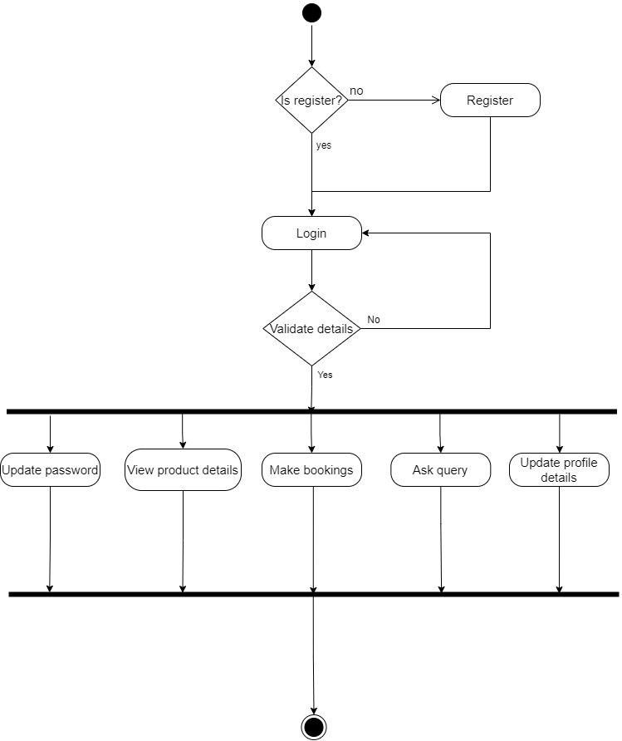

Figure 8.1.1. Activity Diagram.

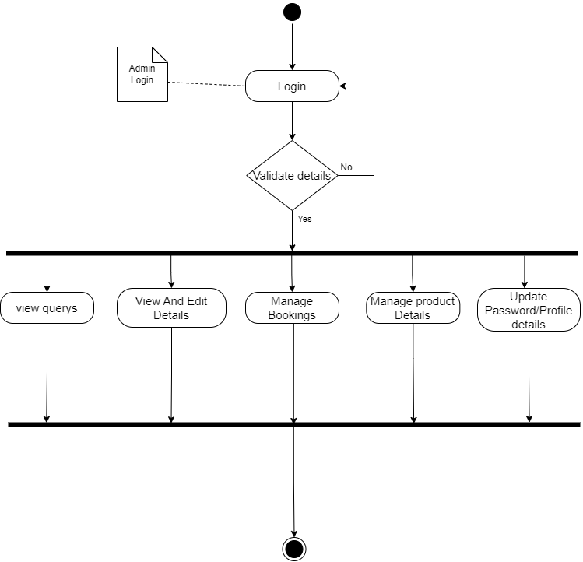

Figure 8.1.2. Activity Diagram.

* 1. **Description of Activity Diagram**

The diagram would start with the "Laptop Rental Request" step, where the customer initiates a request to rent a laptop. This is followed by the "Check Availability" step, where the admin checks if the requested laptop is available for rental.

If the laptop is available, the next step would be the "Collect Customer Information", where the customer's details are collected, including their name, contact information, and payment information.

The next step would be the "Laptop Handover", where the laptop is physically handed over to the customer. This is followed by the "Laptop Usage", where the customer uses the laptop during the rental period.

The activity diagram would also include various decision points, such as the decision to either approve or reject the rental request based on availability, and the decision to either accept or reject the payment information. These decisions would be represented by diamond-shaped symbols.

1. **E-R Diagram**

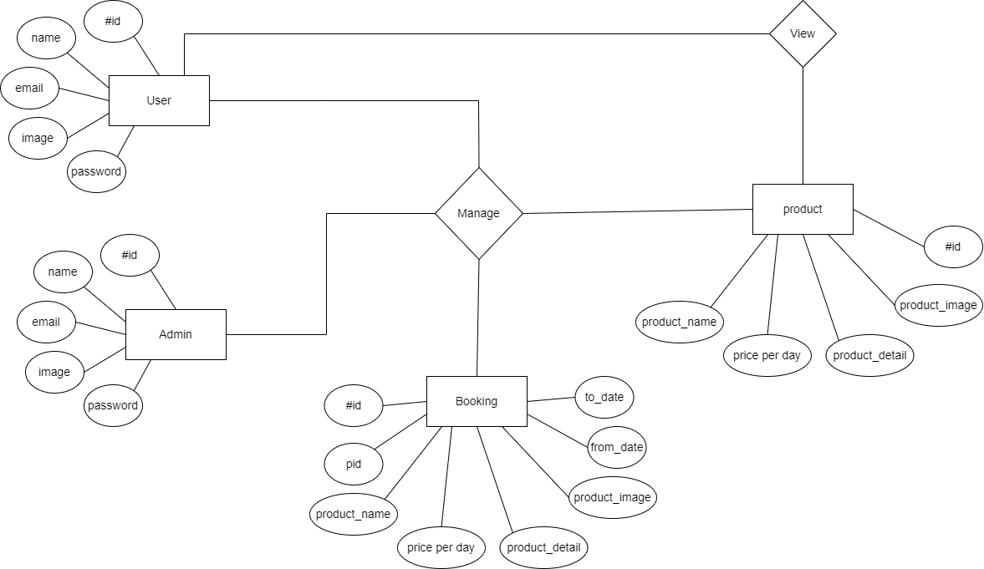

Figure 9.1.1. ER Diagram.

* 1. **Description of E-R Diagram:**

An E-R (Entity-Relationship) diagram is a visual representation of entities and their relationships to each other, used to model a system. For a laptop rental system, the entities and relationships could be represented as follows:

Entities:

1. Customer - a person who rents laptops
2. Laptop - the equipment being rented
3. Rental - a transaction that records the lending of a laptop to a customer

Relationships:

1. A customer can rent multiple laptops, and a laptop can be rented by multiple customers (Many-to-Many)
2. A rental is related to one laptop and one customer (One-to-One)

Attributes:

1. Customer - name, address, contact information, etc.
2. Laptop - model, brand, serial number, etc.
3. Rental - start date, end date, rental fee, etc.

This diagram provides a high-level overview of the data and relationships involved in the laptop rental system, and can be used as a starting point for further design and implementation.

Top of Form

1. **Data Dictionary**
2. **tbluser:**

**Table Description: detail of the users.**

|  |  |  |  |  |  |  |
| --- | --- | --- | --- | --- | --- | --- |
| **Sr. No** | **Field Name** | **Datatype** | **Size** | **Description** | **Constraint** | **Example** |
| 1 | id | int | 100 | Unique id | Not null | 1 |
| 2 | name | varchar | 256 | Name of user | Not null | harshil |
| 3 | email | varchar | 256 | Email of user | Not null | harshil@gmail.com |
| 4 | password | varchar | 256 | Password of user | Not null | 1234 |
| 5 | image | varchar | 256 | Image of user | null | Image1.png |
|  |  |  |  |  |  |  |

1. **tbladmin:**

**Table Description: detail of admin.**

|  |  |  |  |  |  |  |
| --- | --- | --- | --- | --- | --- | --- |
| **Sr. No** | **Field Name** | **Datatype** | **Size** | **Description** | **Constraint** | **Example** |
| 1 | id | int | 100 | Unique id | Not null | 1 |
| 2 | name | varchar | 256 | Name of admin | Not null | admin |
| 3 | email | varchar | 256 | Email of admin | Not null | admin@gmail.com |
| 4 | password | varchar | 256 | Password of admin | Not Null | 1234 |
| 5 | image | varchar | 256 | Image of admin | null | Image1.png |
|  |  |  |  |  |  |  |

1. **tblproduct:**

**Table Description: product detail.**

|  |  |  |  |  |  |  |
| --- | --- | --- | --- | --- | --- | --- |
| **Sr. No** | **Field Name** | **Datatype** | **Size** | **Description** | **Constraint** | **Example** |
| 1 | id | int | 100 | Unique id | Not null | 1 |
| 2 | product_name | varchar | 256 | Name of product | Not null | Lenovo V15 Gen 2 |
| 3 | priceperday | int | 100 | Price of the product | Not null | 200 |
| 4 | product_detail | varchar | 256 | Detail of product | Not null | Designed for the modern workplace, the Lenovo V15 Gen 2 (15, Intel) |
| 5 | product_image | varchar | 256 | Image of product | null | Image1.png |

1. **tblcontactus:**

**Table Description: query ask by users.**

|  |  |  |  |  |  |  |
| --- | --- | --- | --- | --- | --- | --- |
| **Sr. No** | **Field Name** | **Datatype** | **Size** | **Description** | **Constraint** | **Example** |
| 1 | id | int | 100 | Unique id | Not null | 1 |
| 2 | name | varchar | 256 | Name of user | Not null | harshil |
| 3 | email | varchar | 256 | Email of user | Not null | harshil@gmail.com |
| 4 | message | varchar | 256 | message | Not null | Thank you |

1. **tblbooking:**

**Table Description: booking detail**

|  |  |  |  |  |  |  |
| --- | --- | --- | --- | --- | --- | --- |
| **Sr. No** | **Field Name** | **Datatype** | **Size** | **Description** | **Constraint** | **Example** |
| 1 | id | int | 100 | Unique id | Not null | 1 |
| 2 | pid | int | 100 | Product id | Not null | 1 |
| 3 | uid | int | 100 | User id | Not null | 4 |
| 4 | product_name | varchar | 256 | Name of product | Not null | Lenovo V15 Gen 2 |
| 5 | Product_detail | varchar | 256 | Product detail | Not null | Designed for the modern workplace, the Lenovo V15 Gen 2 (15, Intel) |
| 6 | priceperday | int | 100 | Price per day | Not null | 200 |
| 7 | product_image | varchar | 256 | Product Image | null | Image1.png |
| 8 | from_date | date | 8 | Date of booking | Not null | 16-3-2023 |
| 9 | to_date | date | 8 | To date | Not null | 18-3-2023 |
| 10 | status | int | 10 | Status of booking | Not null | 1 |

* 1. **Description of Data Dictionary**

A data dictionary is a structured document that contains information about the data elements in a database or information system. It is a reference tool that describes the data elements and their characteristics, such as the name, data type, length, format, and constraints.

A typical data dictionary includes the following components:

1. Data Element Name: This is the unique name or identifier given to a particular data element.
2. Data Element Description: This provides a detailed description of what the data element represents, its purpose, and its use.
3. Data Type: This specifies the type of data stored in the data element, such as text, numeric, date, etc.
4. Length: This specifies the maximum length of the data element.
5. Format: This specifies the format in which the data element is stored, such as date format, time format, or currency format.
6. Constraints: This specifies any limitations or rules that are imposed on the data element, such as required fields, minimum and maximum values, or unique values.
7. Relationships: This describes the relationships between the data elements in the database or information system.
8. Source: This identifies the source of the data element, such as the system, department, or user.
9. Owner: This identifies the owner of the data element, such as the system owner, department owner, or user owner.

Data dictionaries are useful tools for understanding and managing complex databases or information systems. They provide a standardized way to document data elements, making it easier for users to understand and use the data, and for developers to maintain and modify the system.

1. **Form Design (Screenshots Phase 1 ,2,3,4 & validation’s screenshots)**
   1. **Development Phase -1**

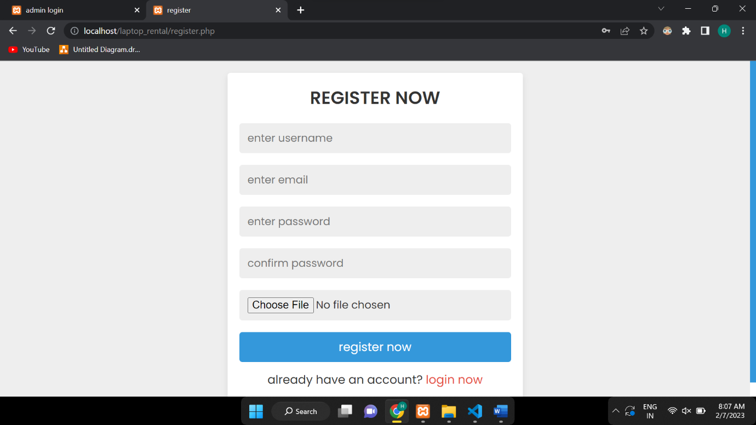

* 1. **Development Phase -2**

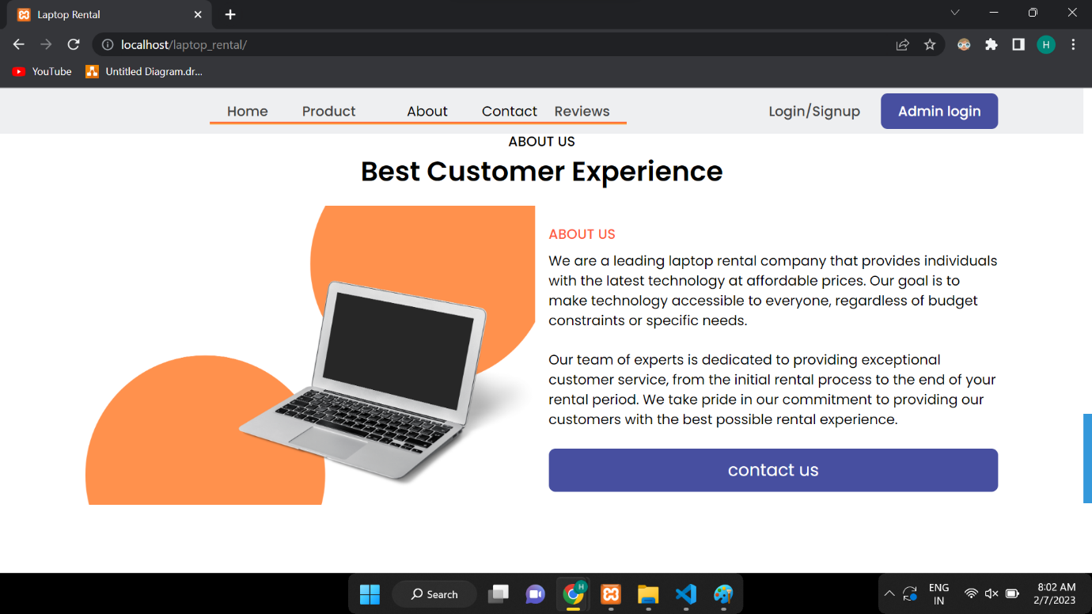

* 1. **Development Phase -3**

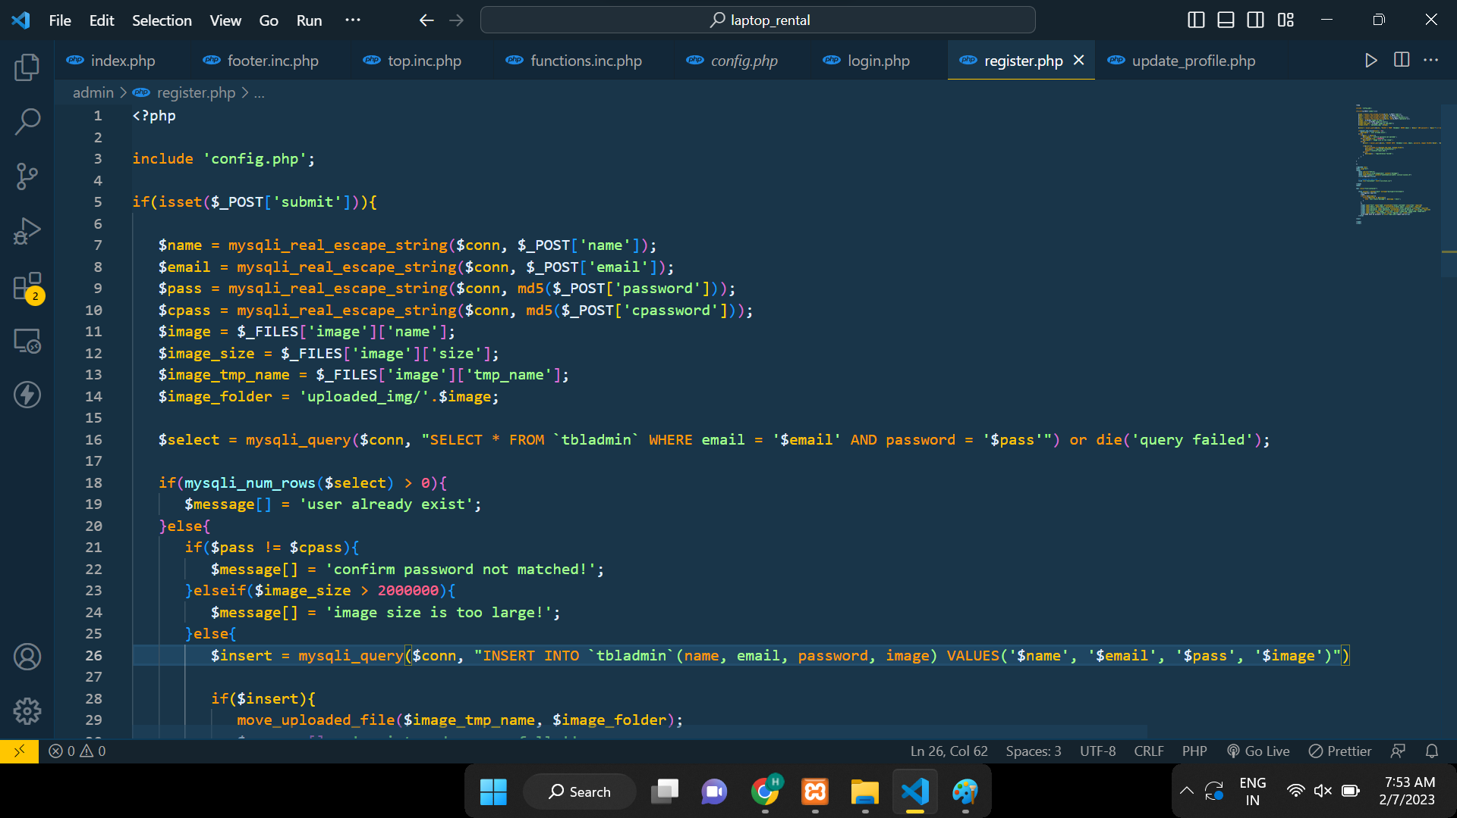

* 1. **Development Phase -4**

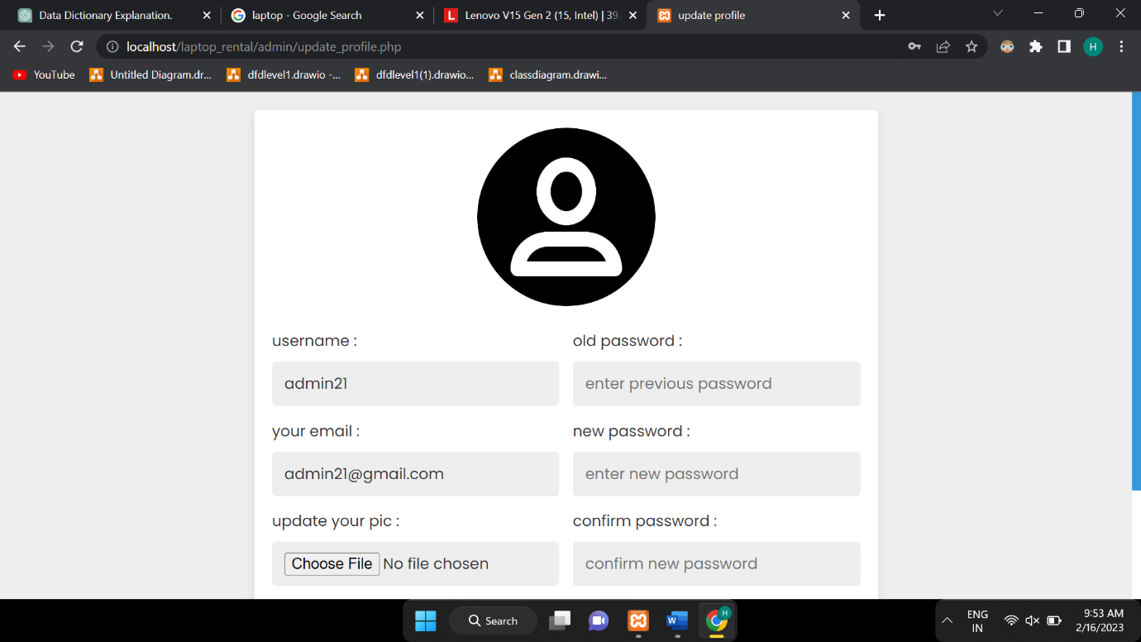

**12. What is testing?**

Testing in software engineering is the process of evaluating a system or its component(s) with the intent to find whether it satisfies the specified requirements or not. It helps to identify any defects, bugs or gaps in the requirements that may have been missed during the development phase.

**12.1. Importance and types of testing**

Testing is an important aspect of software development as it helps to ensure that the software behaves as expected and is free of defects. There are several types of testing that are commonly used, including:

1. Unit testing: This type of testing focuses on individual units or components of the software. Unit tests are usually written by developers and are used to test the functionality of specific code segments.
2. Integration testing: This type of testing focuses on testing the integration of different components of the software. Integration tests are used to verify that the different components of the software work together as expected.
3. Functional testing: This type of testing focuses on testing the software's functionality as a whole. Functional tests are used to verify that the software meets its specified requirements.
4. Performance testing: This type of testing focuses on testing the software's performance and scalability. Performance tests are used to measure the software's performance under different loads and conditions.
5. Acceptance testing: This type of testing focuses on determining whether the software is acceptable for release. Acceptance tests are typically carried out by the customer or end-user.
6. Regression testing: This type of testing focuses on ensuring that changes made to the software do not introduce new defects or break existing functionality.

Overall, testing helps to identify and fix defects early in the development process, which can save time and money. It also helps to ensure that the software meets the needs of the customer and is of high quality.

**13. Future Enhancement**

1.Adding payment module.

2.Add more electronic gadgets.

3.Will allow customers to buy laptops and other gadgets.

**14. References & Bibliography**

1. https://www.youtube.com

2.

<https://www.wikipedia.org>

3.

<https://stackoverflow.com>